PROJECT DOCUMENTATION

**PROJECT PLAN**

| **Project:** | **E-Commerce Website for Skanda.** |
| --- | --- |
| Release: | April 2022 |
| Date: | 24th February 2022 |
|  |  |
| **PRINCE2** |  |
|  |  |
| Author: | S. K. Helani Sihara Jayawardena  (Scheduling Manager) |
| Owner: | Dr Yasas Jayaweera (Project Executive) |
| Client: | SKANDA by Sarasi Samarasundara. |
| Document Ref: | ProjectPlan_SKANDA |
| Version No: | 1.1 |

# 1 Project Plan History

## 1.1 Document Location

This document is only valid on the day it was printed.

The source of the document will be found on the project's PC in the location

## 1.2 Revision History

**Date of this revision: 02/24/2022**

**Date of Next revision:**

| **Revision date** | **Previous revision date** | **Summary of Changes** | **Changes marked** |
| --- | --- | --- | --- |
| 02/24/2022 | 02/15/2022 | Added the Financial Budget, Change Budget, Tolerance |  |

## 1.3 Approvals

This document requires the following approvals.

Signed approval forms are filed in the Management section of the project files.

| **Name** | **Signature** | **Title** | **Date of Issue** | **Version** |
| --- | --- | --- | --- | --- |
| Dr. Yasas Jayaweera |  | Project Board | 02/24/2022 | 1.1 |
| Adithya Narasinghe |  | Project Manager | 02/24/2022 | 1.1 |
| Mrs. Sarasi Samarasundara |  | Client | 02/24/2022 | 1.1 |

## 1.4 Distribution

This document has been distributed to

| **Name** | **Title** | **Date of Issue** | **Version** |
| --- | --- | --- | --- |
| Adithya Narasinghe | Project Manager | 02/24/2022 | 1.1 |
| M. Sonali Silva | Start-up Manager | 02/24/2022 | 1.1 |
| J. M. Pasindu Lawantha Bandara | Quality Manager | 02/24/2022 | 1.1 |
| Madapathage Don Kanishka Gimhan | Risk Manager | 02/24/2022 | 1.1 |
| S. K. Helani Sihara Jayawardena | Scheduling Manager | 02/24/2022 | 1.1 |

# 2 Table of Contents

**1 Project Plan History** **2**

1.1 Document Location 2

1.2 Revision History 2

1.3 Approvals 2

1.4 Distribution 2

**2 Table of Contents** **3**

**Project Plan** **4**

3 Purpose 5

4 Plan Description 5

5 Prerequisites 5

6 Dependencies 5

7 Assumptions 5

8 Project Plan 6

8.1 Work Breakdown Structure. 6

8.2 Gantt Chart. 7

8.3 Product Breakdown Structure 8

8.4 Product Flow Diagrams 9

8.6 Financial Budget 11

8.7 Change Budget 11

8.8 Tolerance 12

8.9 Contingency Plans 12

# Project Plan

## 3 Purpose

The project plan aims to show the significant products, activities, and resources necessary for the project and offer a statement on how and when the project's objectives will be met. It gives the Business Case projected project expenses and management phases, and other significant control points. It serves as a baseline against which the Project Board may track project progress and costs stage by stage.

## 4 Plan Description

The plan includes a full description of the project and the development process.

## 5 Prerequisites

Because it deals with online payments, the customer required the developers to be familiar with user-friendly technology and design a system with high security in mind.

## 6 Dependencies

Tools such as Trello for project management, GitHub for document management, Zoom for communication and, MS Word and google docs for writing reports will be used in carrying out this entire project.

Other than that, WordPress and WooCommerce will be used to build the system.

## 7 Assumptions

The team assumes that the client has the general IT literacy to operate the easy to use website after the deployment.

The team also assumes that a Shared Hosting plan(which will cost around $40 per year) will have enough performance to host the website and accommodate its traffic. This is due to the fact that the client wants to get it done at a minimal cost.

## 8 Project Plan

### 8.1 Work Breakdown Structure.

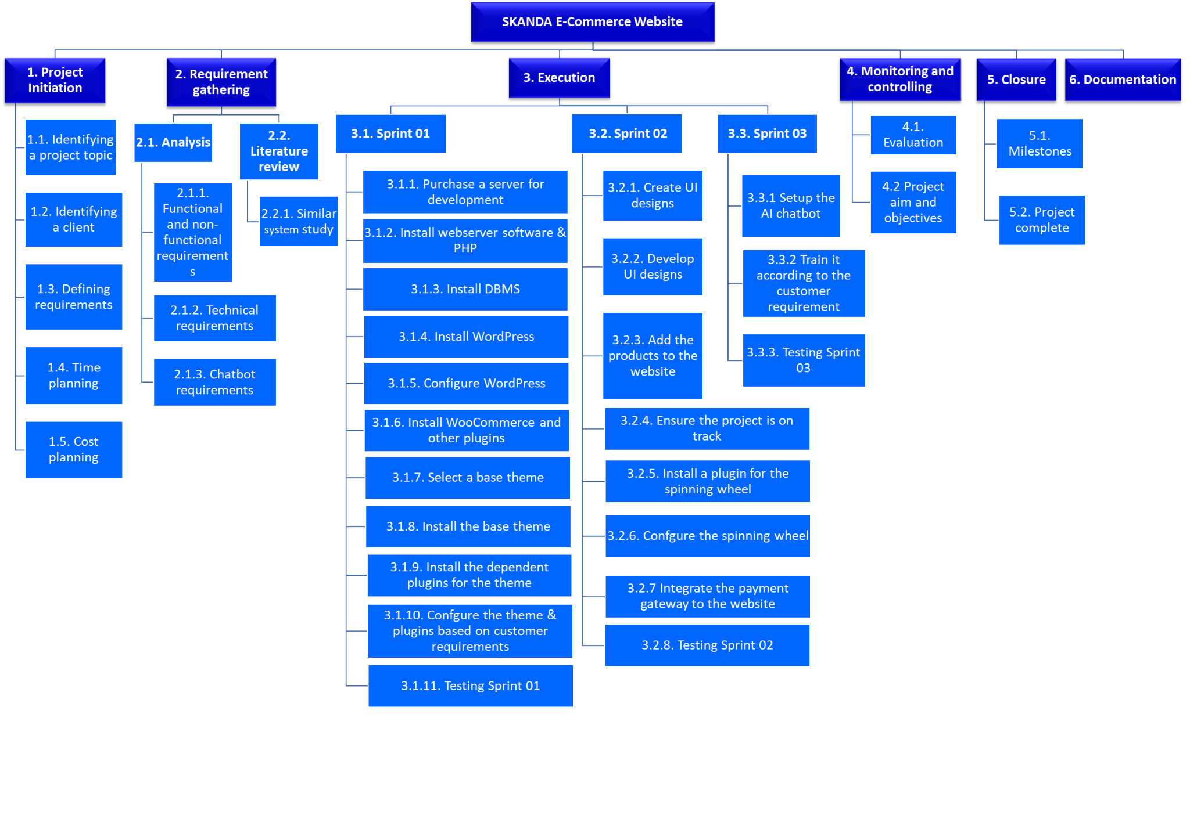

### 8.2 Gantt Chart.

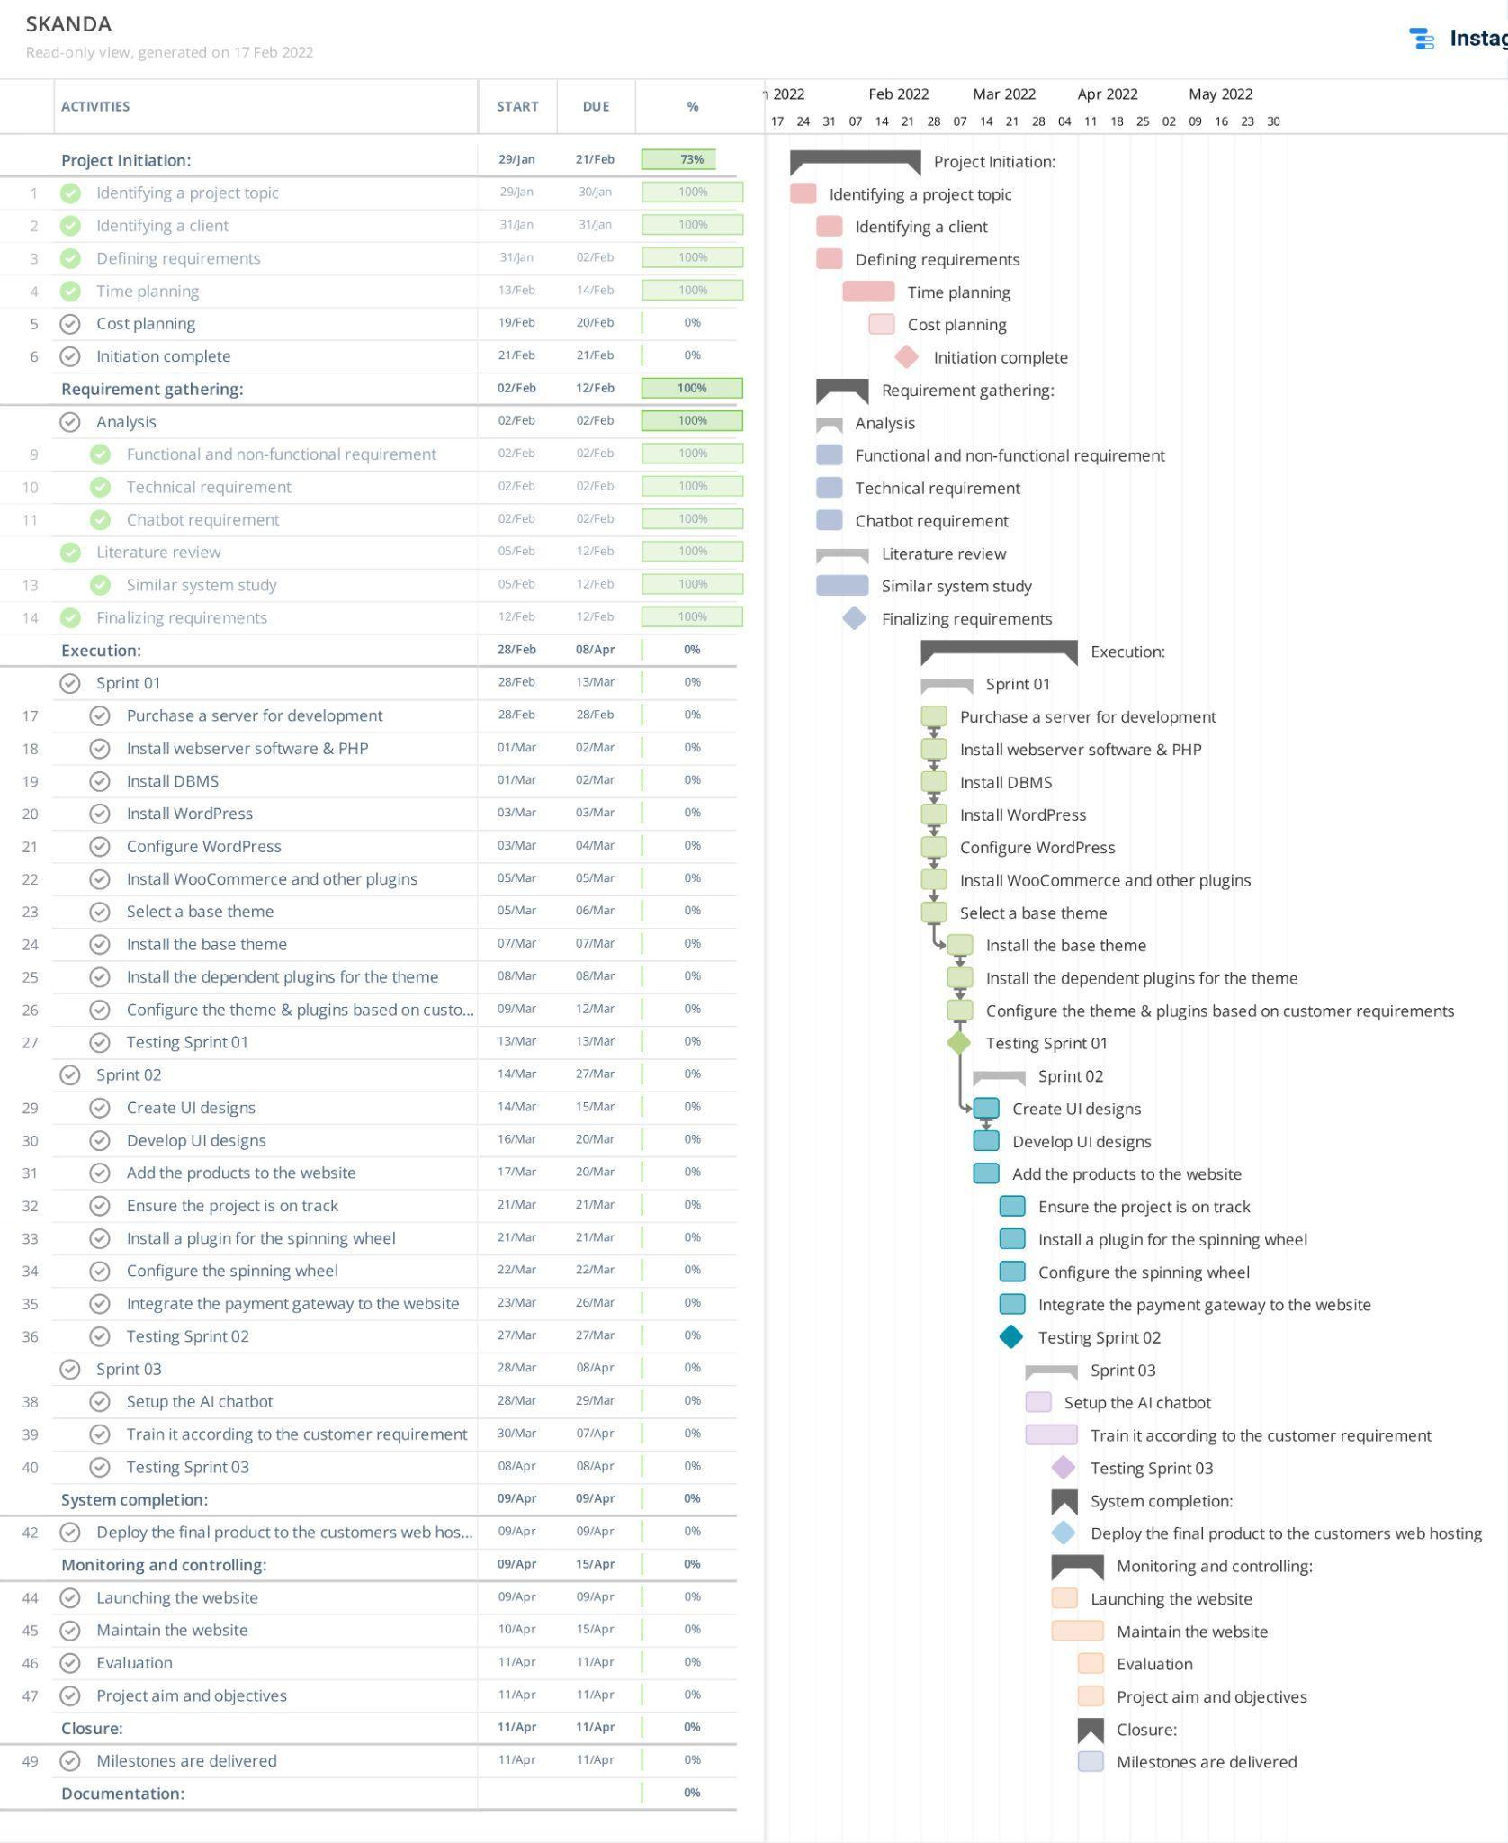

### 8.3 Product Breakdown Structure

### 

### 

### 8.4 Product Flow Diagrams

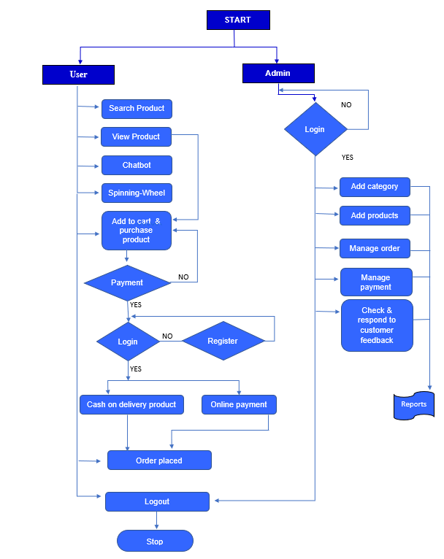

**8.5 Product Descriptions**

The product description document explains the depth of the product. The final product is a website that will be hosted on a web server and has the following features.

**Website (Front-End)**

* Create User Account
* View Products
* Make Online Payments
* Purchase Product
* AI-based Chatbot
* Search for products
* Change Account Settings
* View and Manage Shopping Cart

**Admin Panel**

* Add Products
* View Products
* View and Manage Orders
* Manage Categories
* Change Account Settings
* Edit/delete/update products
* Update availability of products

### 

### 

### 

### 

### 

### 

### 

### 

### 

### 8.6 Financial Budget

**Estimated Budget For SKANDA**

**by Sarasi Samarasundara.**

**(E-Commerce Website)**

| **Expense** | **Description** | **Basis** | **Unit** | **Rate**  **(Rs.)** | **Amount (Rs.)** |
| --- | --- | --- | --- | --- | --- |
| **Charges for the set up** | | | | | |
| Domain Purchasing | Registration of Domain | Domain Per Year | 1 | 5,000.00 | 5,000.00 |
| Purchasing a hosting service | Purchase of space for Hosting | Per Year | 1 | 8,000.00 | 8,000.00 |
| Purchasing a WordPress template. | Purchasing a WordPress template that matches the finalised designs. | One time purchase | 1 | 12,000.00 | 12,000.00 |
| Payment gateway subscription | Subscribing to a payment gateway to get the service | Per Year | 1 | 35,880.00 | 35,880.00 |
| **Planning** | | | | | |
| Client Requirement Gathering | Understanding the Requirement & Consultation. | Per Hour | 4 | 1,500.00 | 6,000.00 |
| Other Expenses | Printouts & Photocopy | Per Copy | 100 | 10.00 | 1,000.00 |
| **Design and Development** | | | | | |
| Content Writing | Copywriting for the web pages and how to use documents | Per Hour | 20 | 500.00 | 10,000.00 |
| Web Design and Development | Creating & configuring the website based on the approved Design & Specification | Per Hour | 40 | 1,000.00 | 40,000.00 |
| Graphic Designs | Creating graphics for the website | Per Artwork | 15 | 1,000.00 | 15,000.00 |
| **Deployment** | | | | | |
| Final Review & Deployment | Final Testing and Deployment of the website | Per Hour | 15 | 1000.00 | 15,000.00 |
| **Total Estimated Cost** | | | | | **147,880.00** |

### 

### 8.7 Change Budget

There has been no change in the budget since the client agreed with it.

### 

### 8.8 Tolerance

Due to the commitments of the developers in their undergraduate project, work & personal life, the clients were gracious enough to give an extra month for the full implementation on a condition that the project mustn't in any way be of low quality.

### 8.9 Contingency Plans

All the changes will be saved to the database of the webserver and daily backups will be taken and uploaded to a separate cloud service, and all documents will be saved to Google Drive in the event that they are accidentally deleted from the developers' computer. Because they are stored on the cloud, they are unlikely to get lost and obstruct the project's progress.